**Lesson 01 Demo 05**

**Exploring Multimodal Capabilities of ChatGPT**



**Objective:** To demonstrate ChatGPT's multimodal capabilities by analyzing a geographical map and creating a visualization of a futuristic smart city park

**Tools required:** ChatGPT-4

**Prerequisites:** None

**Steps to be followed:**

1. Log in to ChatGPT and select GPT4
2. Copy the prompt with the image, and paste it into ChatGPT
3. Observe the response
4. Copy the prompt with the image, and paste it into ChatGPT
5. Observe the response

**Step 1: Log in to ChatGPT and select GPT4**

To proceed with your tasks, visit the official website and either sign up for a new account or log in to your existing ChatGPT account.

<https://chat.openai.com/>

**Step 2: Copy the following prompt and image, and paste them into ChatGPT**

**Prompt 1:**

Analyze the image provided, which is a map featuring various geographical locations, including cities, states, and natural landmarks. Identify the country and suggest notable tourist attractions visible on the map. Describe these places briefly and explain their significance or appeal to visitors, focusing on areas that are typically of interest to travelers, such as major urban centers, historical sites, natural parks, and unique regional features.

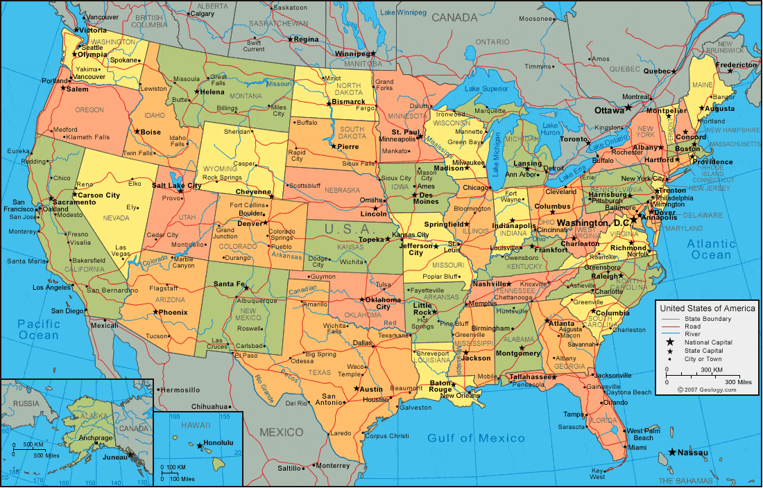

**Step 3: Observe the response**

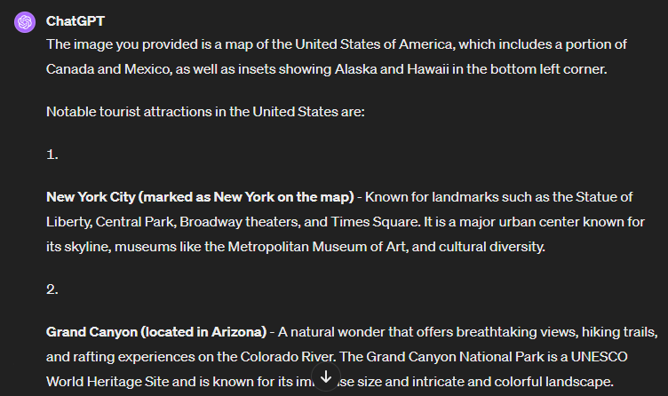

**Step 3: Copy the following prompt and image, and paste them into ChatGPT**

**Prompt 2:**

Create an image of a futuristic smart city park at twilight. The scene should depict an eco-friendly environment where technology and nature are seamlessly integrated. Include solar-paneled walkways, bioluminescent plants, interactive digital information boards that display park details, and people enjoying the surroundings. The atmosphere should be serene with soft lighting, and the sky should show the transition from sunset to starry night. In the background, there should be a skyline of sustainable skyscrapers with green rooftops and vertical gardens. This visualization should embody the harmonious blend of urban development with environmental conservation, highlighting the potential of generative AI in urban planning and design.

**Step 3: Observe the response**

